**8-Bit Bang! - Game Design Document**

**Team BeetleBorgs**

**Table of Contents**

1. **Overview**
2. **Game Concept**
3. **Gameplay Mechanics**
4. **Game Flow**
5. **Level Design**
6. **Visual Style & Aesthetics**
7. **Audio Design**
8. **User Interface (UI)**
9. **Technical Architecture**
10. **Tools & Technologies**
11. **Scoring & Progression**
12. **Boss Mechanics**
13. **Player Experience Goals**
14. **Inspirations & References**
15. **Future Development & Roadmap**

**1. Overview**

**Game Title: 8-bit Bang!  
Genre: Action / Reflex / Arcade Western  
Platform: PC (Windows)  
Engine: Unreal Engine (Blueprint based)  
Perspective: Side View (2D gameplay with 3D aesthetics)  
Target Audience: Casual gamers, retro lovers, arcade fans**

**2. Game Concept**

**8-bit Bang! is a reaction-based cowboy dueling game inspired by classic western movies. The game makes use of traditional quickdraw shootouts, combining the charm of 8-bit pixel art characters with the depth and atmosphere of realistic, high-quality backgrounds. The goal is to win as many duels as possible in a row by reacting faster than the enemy.**

**The core of the game revolves around anticipation, timing, and split-second decision-making. Each round is a face-off where both the player and the enemy must wait for a signal before they can shoot. If the player shoots too early or too late, the round is lost. The game increases in difficulty over time, and every 10 rounds a special boss appears with unique challenges.**

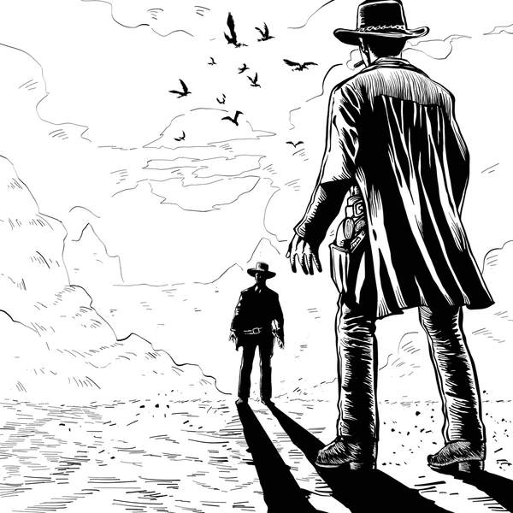

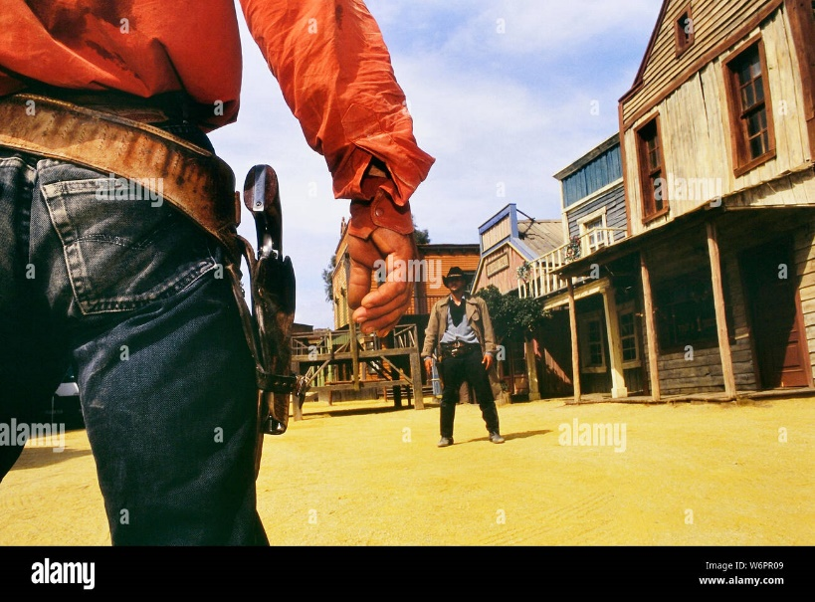

**3. Gameplay Mechanics**

**Core Loop:**

* **Player and enemy stand opposite each other in a duel.**
* **A randomized delay occurs.**
* **A visual signal (Exclamation Mark !) appears.**
* **Player must press the Spacebar as quickly as possible after the signal.**
* **If player is quicker: Win the round.**
* **If enemy is quicker or player shoots early: Lose the round.**

**Controls:**

* **SPACEBAR – Shoot**
* **ESC – Pause / Exit to menu**

**Rules:**

* **Shooting before the signal results in an instant loss.**
* **Every duel is one-shot only.**
* **Player wins 100 points for normal enemies and 500 points for bosses.**

**4. Game Flow**

1. **Main Menu**
   * **Start Game**
   * **How to Play**
   * **Credits**
   * **Exit**
2. **Tutorial (Optional)**
   * **Brief instructions**
   * **Practice duel with slower timing**
3. **Regular Rounds (1–9)**
   * **Standard duels**
   * **Random enemy appearance**
   * **Increasing difficulty curve (faster reaction windows)**
4. **Boss Rounds (Every 10th round)**
   * **Unique enemy character with animations**
   * **Slightly faster reaction time required**
   * **Background music changes**
5. **End Game**
   * **Player loses any round**
   * **Final score shown**
   * **Option to retry or return to menu**

**5. Level Design**

**Standard Duels:**

* **Each level is a scene with different realistic backgrounds: desert, canyons, saloons, abandoned towns, etc.**
* **Backgrounds are selected randomly to maintain freshness.**
* **Ambient elements such as moving dust, day-night transitions enhance realism.**

**Boss Levels:**

* **Visually distinct environments with darker lighting or thematic changes.**
* **May include light distractions or visual effects to increase challenge.**

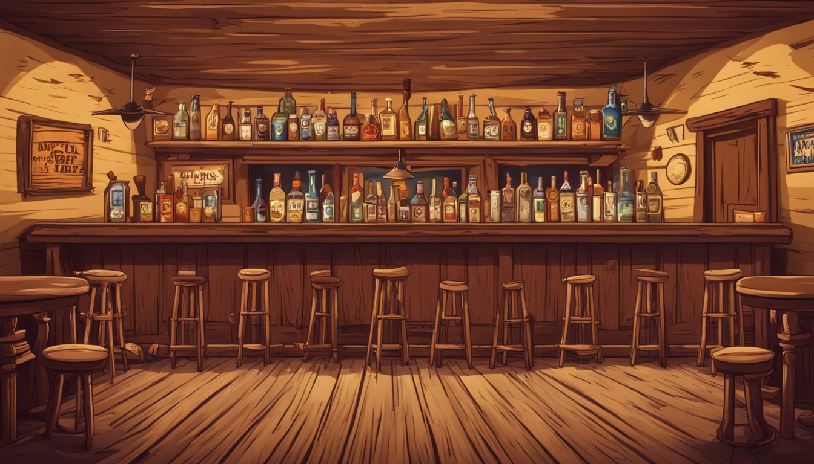

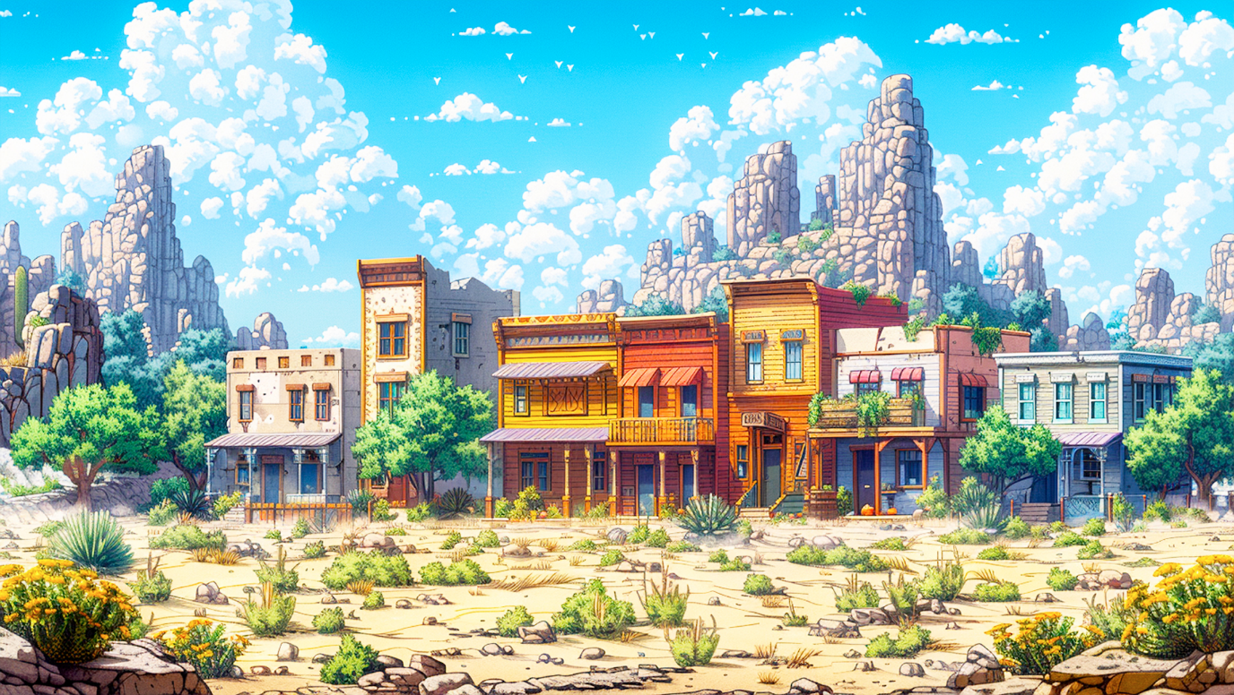

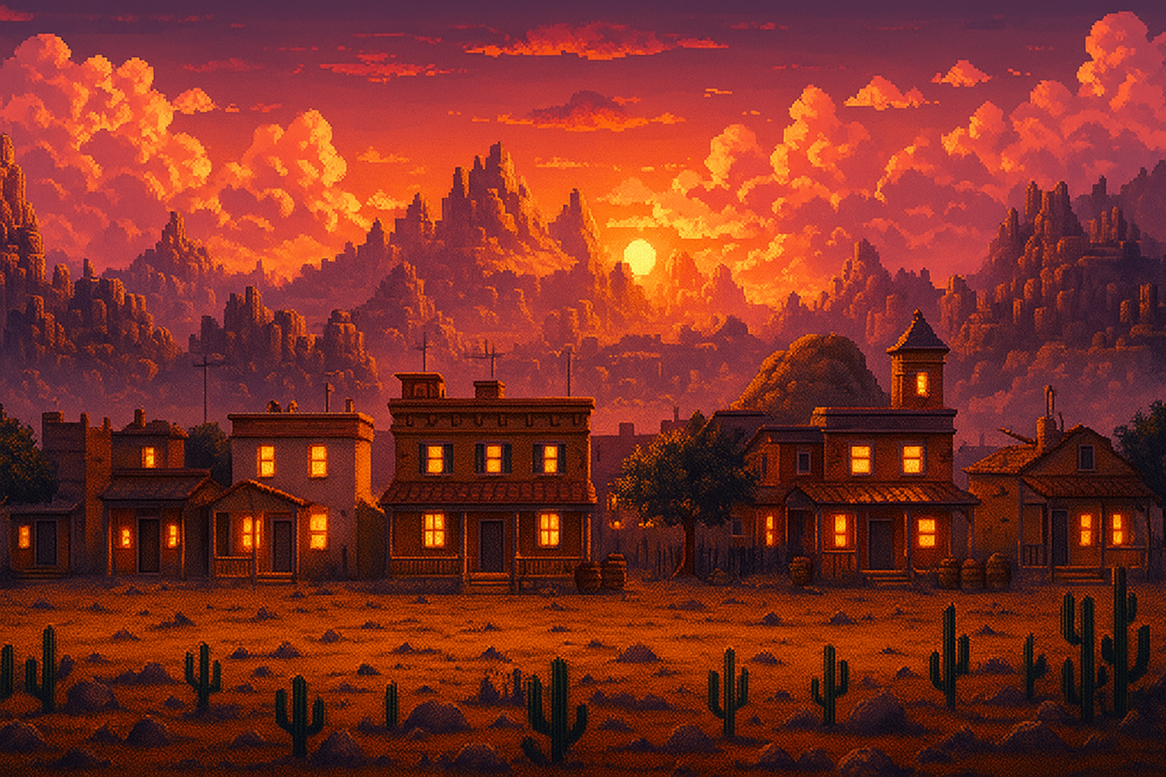

**6. Visual Style & Aesthetics**

**Characters:**

* **All characters (player, enemies, bosses) are created in 8-bit pixel art style.**
* **Animations: idle, draw gun, shoot, fall down (if hit), taunt (bosses).**

**Environment:**

* **High-resolution, realistic backdrops.**
* **Lighting and shadow layers added to simulate depth.**
* **2D-3D hybrid aesthetic provides a nostalgic-modern contrast.**

**Animation Style:**

* **Frame-by-frame sprite animation.**
* **Bosses have more detailed and expressive animation sets.**

 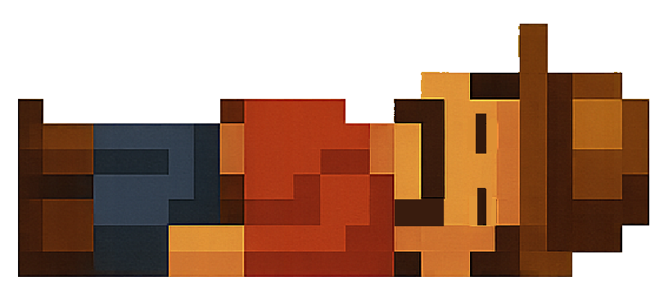

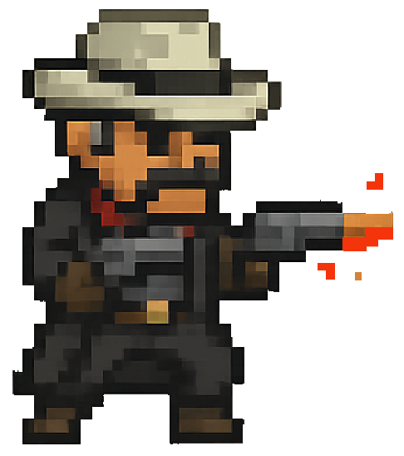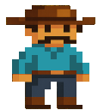

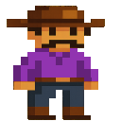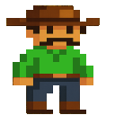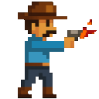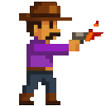



**Main Screen**



**Level Screen**



**How To Play Screen**

**7. Audio Design**

**Music:**

* **Background music inspired by classic Western soundtracks (Ennio Morricone style).**
* **Separate soundtracks for normal duels and boss battles.**

**Sound Effects:**

* **Gunfire (8-bit style)**
* **Footsteps, wind, birds (realistic)**
* **Exclamation mark cue sound**
* **Death or defeat sound effect**

**8. User Interface (UI)**

* **Retro pixel-themed HUD**
* **Round number**
* **Score counter**
* **Animated exclamation mark (!)**
* **Shooting timer bar (boss levels only)**

**Menus:**

* **Main Menu: Title screen with How to play**
* **Game Over Screen: Switch back to Main Menu**

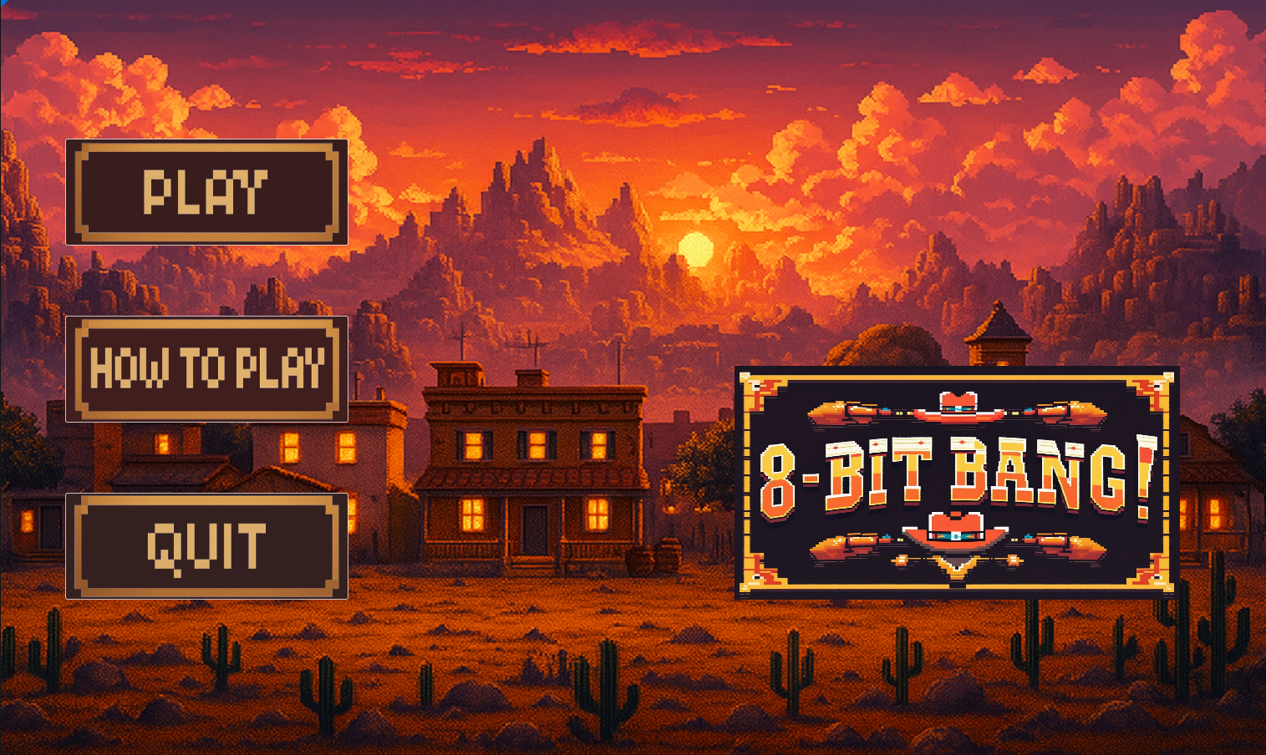

**9. Technical Architecture**

* **Engine: Unreal Engine (Blueprint)**
* **Graphics Pipeline: 2D sprites (Flipbook animations) with 3D camera and lighting layers**
* **State Machine: Handles game phases (Start > Duel > Result > Next / Game Over)**
* **Timer System: Manages randomized signal delay and input timing**

**10. Tools & Technologies**

* **Unreal Engine 5.3.2**
* **Piskel for sprite creation**
* **Audacity / FL Studio for audio editing**
* **Blender (for background compositing and lighting FX)**

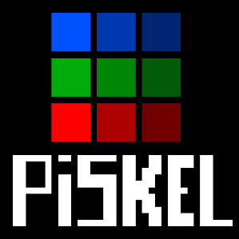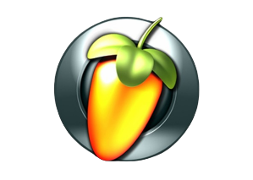

**11. Scoring & Progression**

|  |  |
| --- | --- |
| **Event** | **Points Awarded** |
| **Win Standard Round** | **100 Points** |
| **Win Boss Round** | **500 Points** |

* **Score is displayed in real-time.**
* **High score stored locally.**
* **Leaderboard implementation is optional for future builds.**

**12. Boss Mechanics**

* **Boss appears every 5 rounds.**
* **Has special animations and faster trigger speed.**
* **Background changes to reflect increased tension.**
* **May include slight distractions (e.g., flickering lights, animals running in background).**
* **Audio shifts to more intense, darker theme.**

**13. Player Experience Goals**

* **Create intense, bite-sized moments of tension and satisfaction.**
* **Reward reflexes and attention to detail.**
* **Evoke retro charm while keeping visuals rich and immersive.**
* **Deliver replayability through high scores and escalating difficulty.**

**14. Inspirations & References**

* **Movies: The Good, the Bad and the Ugly, Django Unchained**
* **Games: Wild Gunman, Cuphead (boss flow), Octopath Traveler (art style fusion)**
* **Art Style: 8-bit pixel characters with realistic settings**

**15. Future Development & Roadmap**

**Planned Features:**

* **Local multiplayer (duel with a friend)**
* **Achievements (e.g., 50 duels survived)**
* **Player customization (hats, cloaks, skins)**
* **Unlockable boss duels in arcade mode**
* **Steam release with online leaderboard**